**SQL VS PLSQL:**

SQL, Structural Query Language is a standard database language which is used create, maintain and retrieve the relational database whereas PL/SQL, Procedural Language extension to SQL, it extends SQL and provide it procedural capabilities.

| **Sr. No.** | **Key** | **SQL** | **PL/SQL** |
| --- | --- | --- | --- |
| 1 | Definition | SQL, is Structural Query Language for database. | PL/SQL is a **programming language** using SQL for a database. |
| 2 | Variables | SQL has no variables. | PL/SQL has variables, data types etc. |
| 3 | Control Structures | SQL has no FOR loop, if control and similar structures. | PL/SQL has FOR loop, while loop, if controls and other similar structures. |
| 4 | Operations | SQL can execute a single operation at a time. | PL/SQL can perform multiple operation at a time. |
| 5 | Language Type | SQL is a declarative language. | PL/SQL is a procedural language. |
| 6 | Embedded | SQL can be embedded in a PL/SQL block. | PL/SQL can also be embedded in SQL code. |
| 7 | Interaction | SQL directly interacts with database server. | PL/SQL does not directly interacts with database server. |
| 8 | Orientation | SQL is data-oriented language. | PL/SQL is application-oriented language. |
| 9 | Objective | SQL is used to write queries, create and execute DDL and DML statements. | PL/SQL is used to write program blocks, functions, procedures, triggers and packages. |

Allows execution of a block of a code at any time which increases its performance basically enhancing the actual powerful SQL language.

This block of code can be procedures, functions, triggers, loops, variables.





<https://www.youtube.com/watch?v=SRZehj9FOUE>

In SQL, only one statement can be sent to Oracle Engine. It increases the execution time. In PL/SQL, a complete block of code can be sent to Oracle engine at a time, reducing traffic.

In SQL, there is no facility of error management. In case of an error condition, it is Oracle engine that tracks it. In PL/SQL, the error management capacity is available. In case of error, PL/SQL automatically gives the related message.

In PL/SQL, the result of the statement can be stored in variables and can be used further as per the requirements.

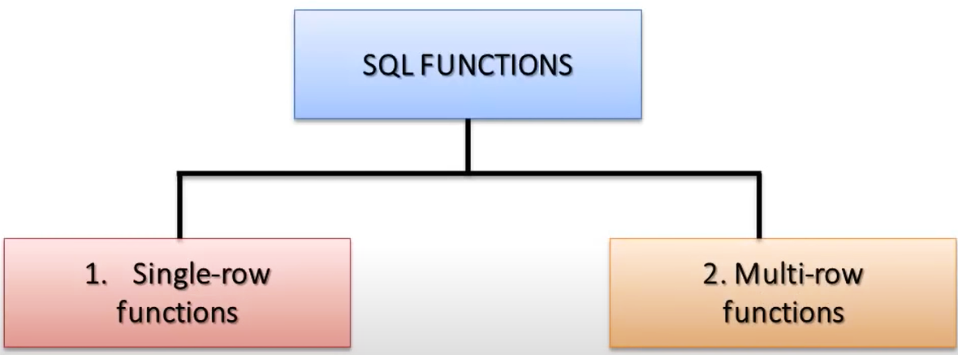

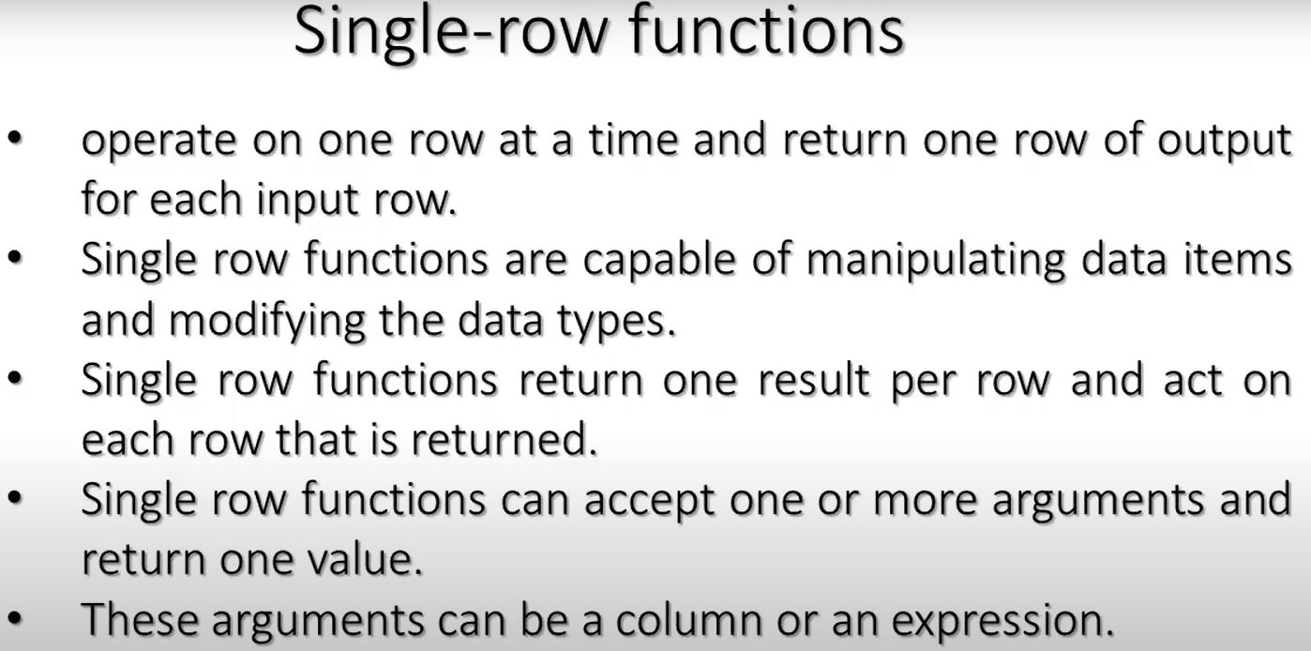

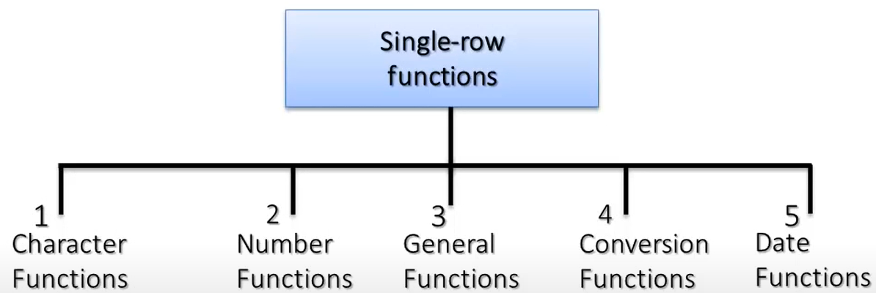

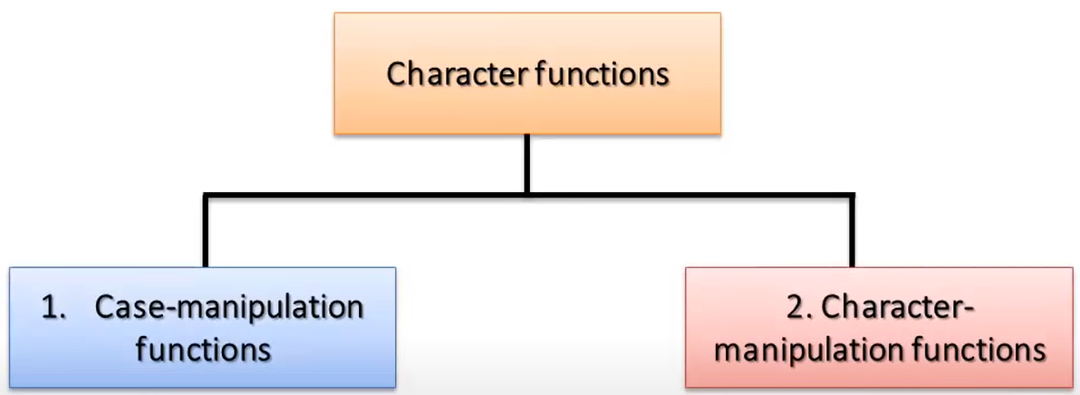

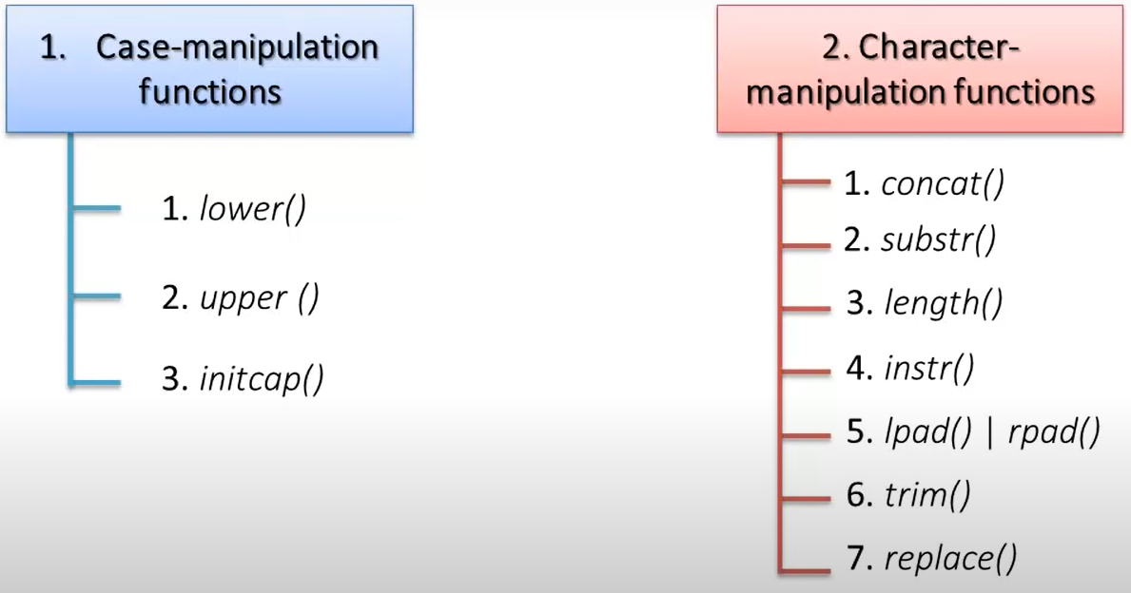

Initcap() --🡪 Converts the Initial letter of each word to Upper Case.

Oracle provides you with the DUAL table which is a special table that belongs to the schema of the user SYS but it is accessible to all users.

The DUAL table has one column named DUMMY whose [data type](https://www.oracletutorial.com/plsql-tutorial/plsql-data-types/) is [VARCHAR2()](https://www.oracletutorial.com/oracle-basics/oracle-varchar2/) and contains one row with a value X.

By using the DUAL table, you can execute queries that contain functions that do not involve any table like the [UPPER()](https://www.oracletutorial.com/oracle-string-functions/oracle-upper/) function as follows:

**SELECT**

**UPPER**('This is a string')

**FROM**

dual;

Besides calling built-in function, you can use expressions in the SELECT clause of a query that accesses the DUAL table:

**SELECT** (10 + 5)/2 **FROM** dual;

The DUAL table is most simple one because it was designed for fast access.

In Oracle 10g release 1 and above, Oracle treats the use of DUAL the same as calling a function which simply evaluates the expression used in the select list. This optimization provides even better performance than directly accessing the physical DUAL table.

DUAL is a table automatically created by Oracle Database along with the data dictionary. DUAL is in the schema of the user SYS but is accessible by the name DUAL to all users. It has one column, DUMMY, defined to be VARCHAR2(1), and contains one row with a value X. Selecting from the DUAL table is useful for computing a constant expression with the SELECT statement. Because DUAL has only one row, the constant is returned only once. Alternatively, you can select a constant, pseudocolumn, or expression from any table, but the value will be returned as many times as there are rows in the table. Please refer to ["SQL Functions"](https://docs.oracle.com/cd/B19306_01/server.102/b14200/functions001.htm#i88893) for many examples of selecting a constant value from DUAL.

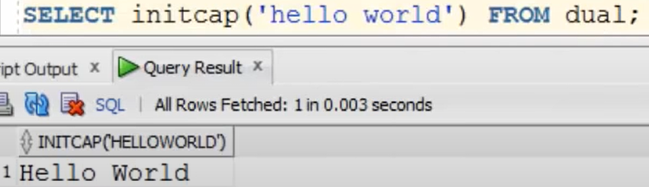

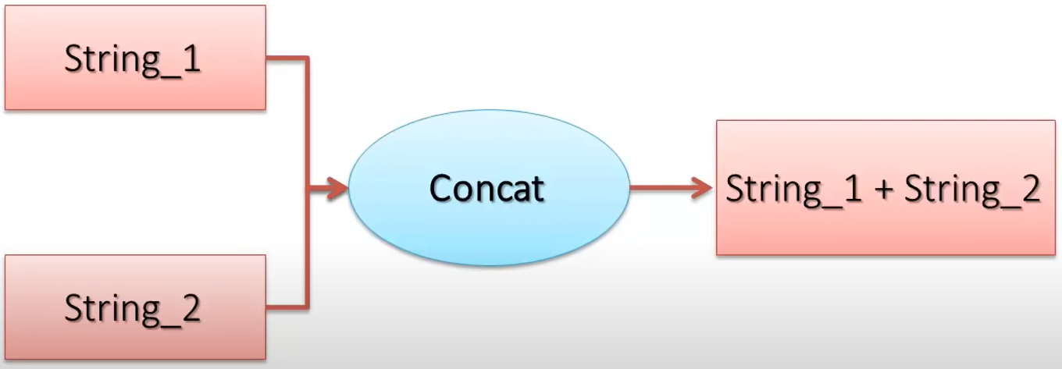

Diff btw Concat function and concatenation operator??

Concat function is used to concat only 2 strings, while the operator can be used again anad again to oncat many strings.

Concat operator Is also not supported by Several databases like Sql Server.



Above concats the two strings without space.

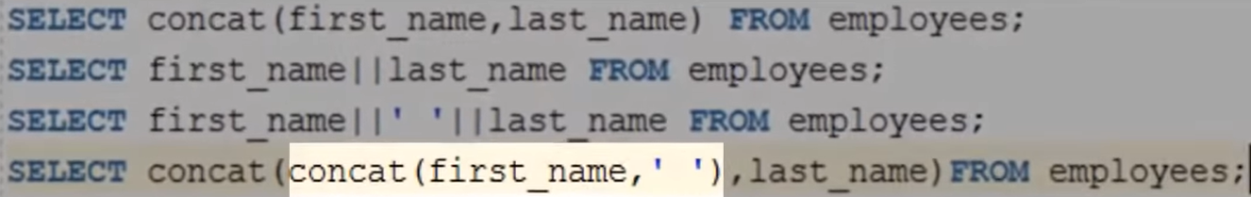



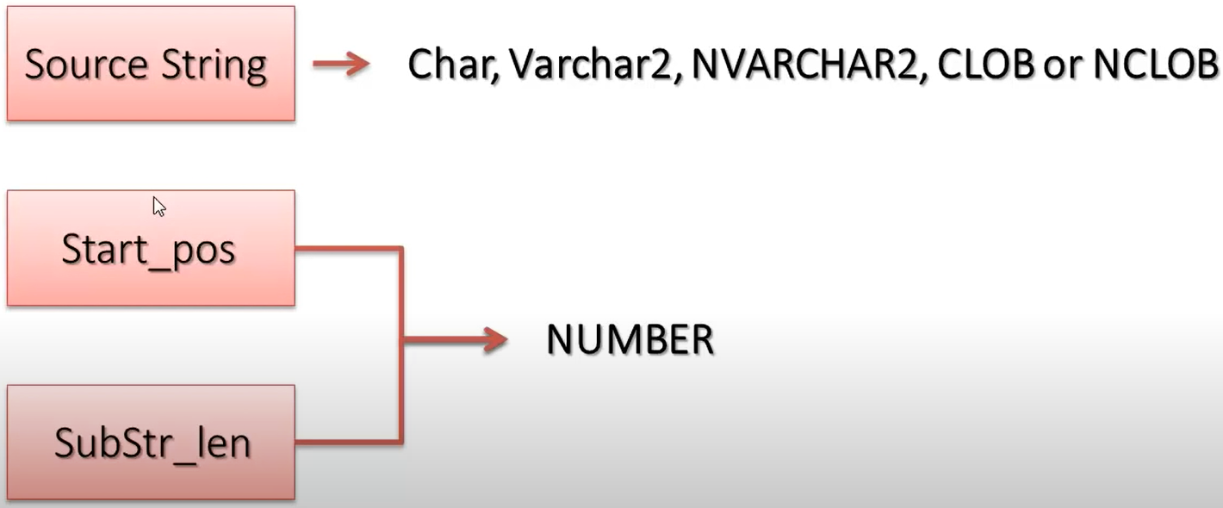

1. When start_pos > Source_str == > Result is NULL
2. When SubStr_len > Source_Str 🡺 Return a substring from Start_pos to the End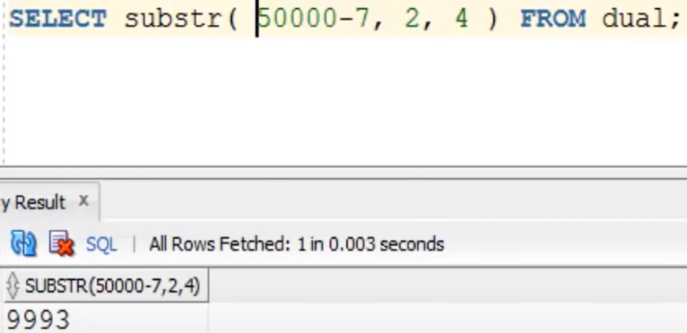

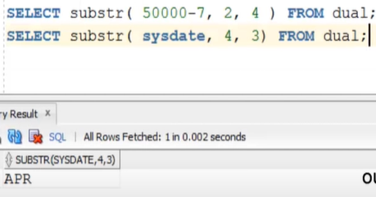

To create tables, we use sql Create table command.

SQL create table Is a type of Data Definition Language (DDL). To create table in your schema, you will be requiring Create table System privileges.

DESC <Table_Name> 🡨---------- to get the table description (For Oracle).

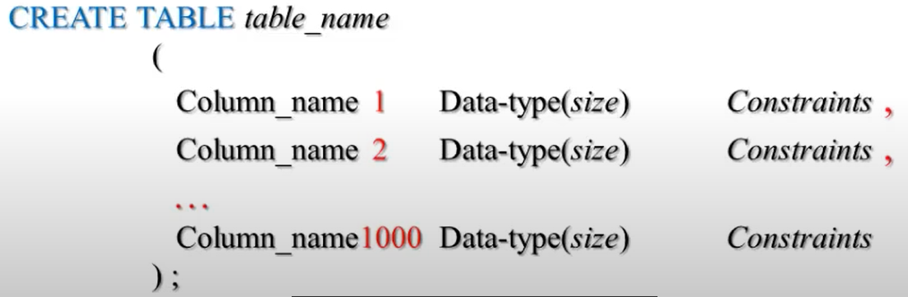

It can be done thorugh

1. Command Line Interface
2. GUI (SQL Developer)
3. Enterprice Manager

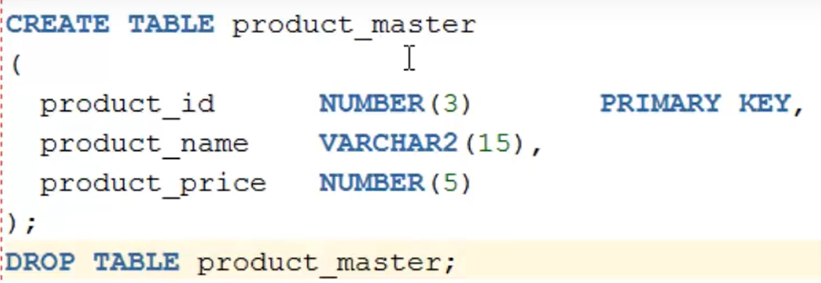

Above, oracle server will create a PK on product_id with a default constraint name.

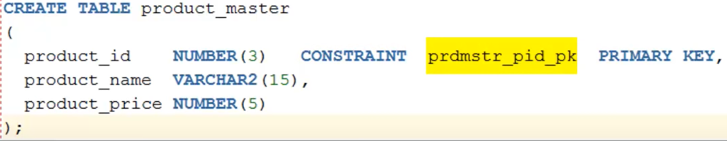

DEFINING PRIMARY KEY CONSTANT AT TABLE LEVEL:

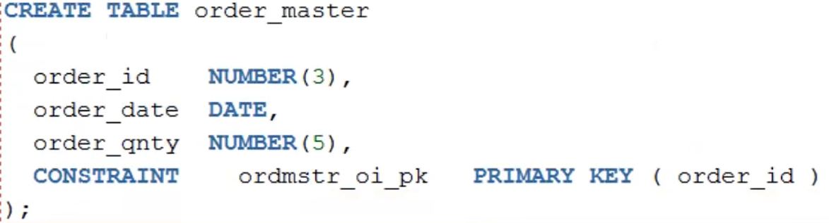

Add PK on a table which is already created 🡪 Use Alter keywork



CREATING A COMPOSITE PK AND DROPPING A PRIMARY KEY OF A TABLE:

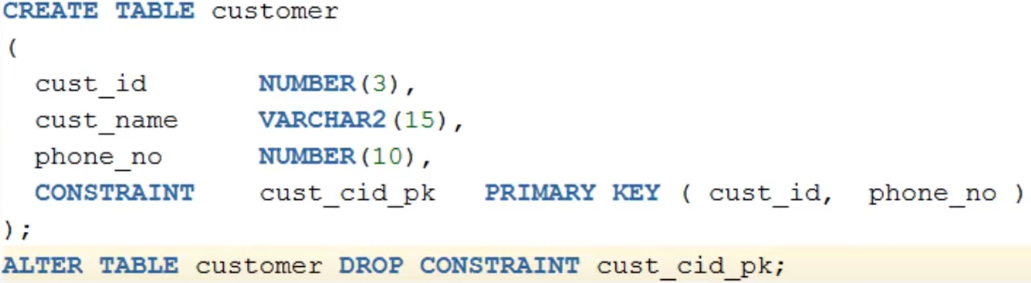

For Foreign Key , the column must have the same data type and the Size of the PK column.

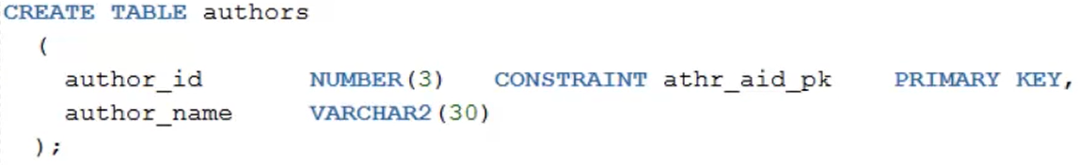

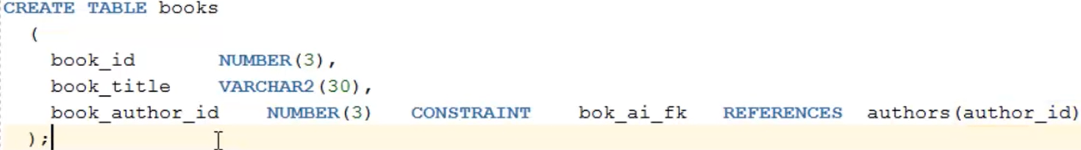

Creating Foreign On Table Level.

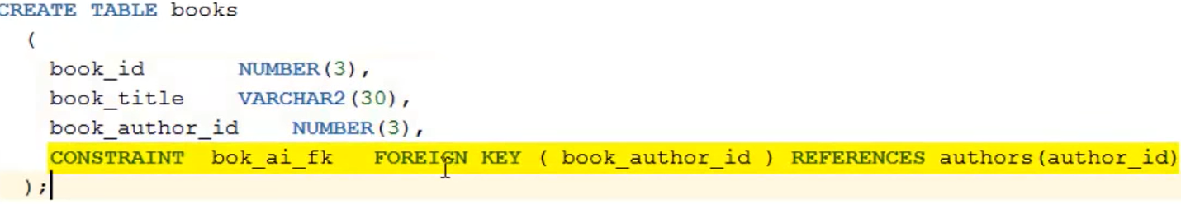

**Difference between varchar and varchar2**

|  |  |
| --- | --- |
| **Varchar** | **Varchar2** |
| 1) Varchar can identify NULL and empty string separately. | 1) Varchar2 cannot identify both separately. Both considered as same for this. |
| 2) Varchar can store minimum 1 and maximum 2000 bytes of character data. | 2) Varchar2 can store minimum 1 and maximum 4000 bytes of character data. |
| 3) Allocate fixed size of data irrespective of the input.  Ex: We defined varchar (15) and entered only 10 characters. But it allocates space for entire 15 characters. | 3) Allocate variable size of data based on input.  Ex: We defined varchar2 (15) and entered only 10 characters. Then varchar2 will allocate space for 10 characters only but not for 15. |
| 4) For varchar data, extra spaces are padded to the right side. | 4) For varchar2 extra spaces will be truncated. |
| 5) Varchar is ANSI Sql standard | 5) Varchar2 is Oracle standard |
| 6) Varchar definition may change in future. | 6) Varchar2 definition will not change. It is standard. |
| 7) Varchar is an external datatype. | 7) Varchar2 is an internal datatype. |

LPAD and RPAD:

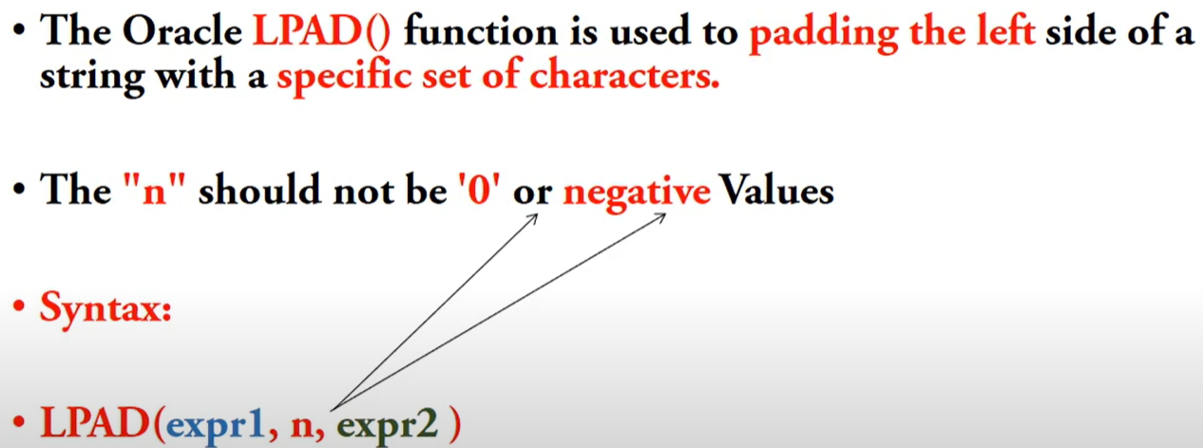

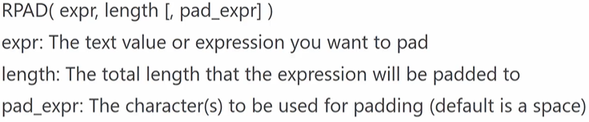

TRIM::

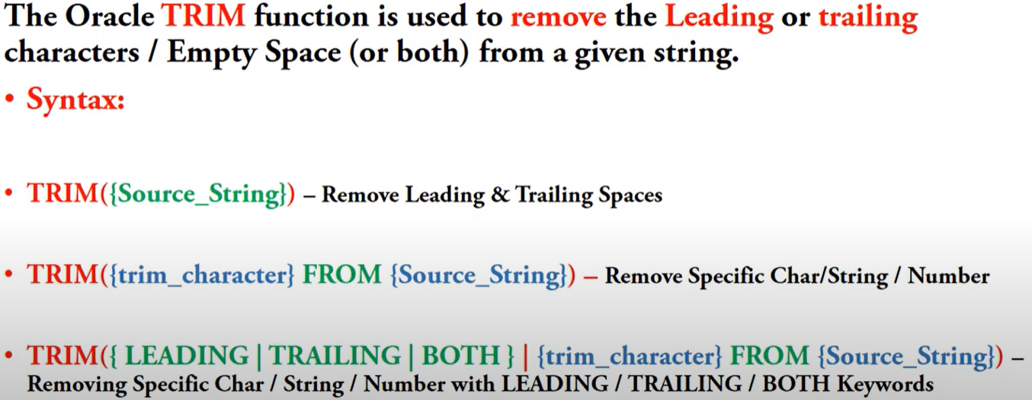

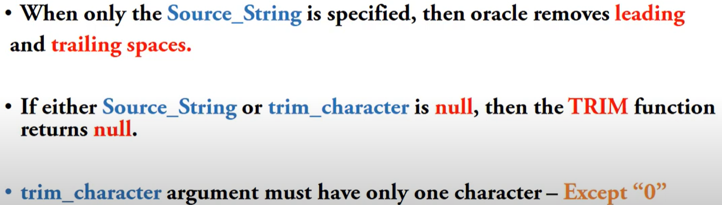

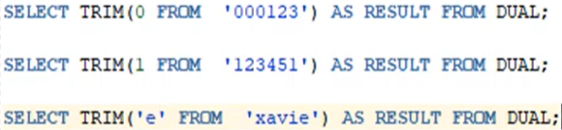

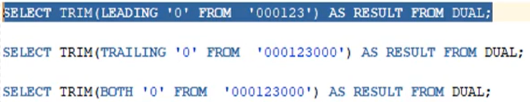

The trim character should have only one character except 0 or an Error is thrown.



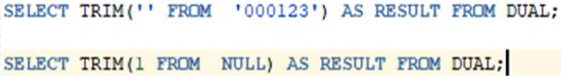

The above ones returns null.

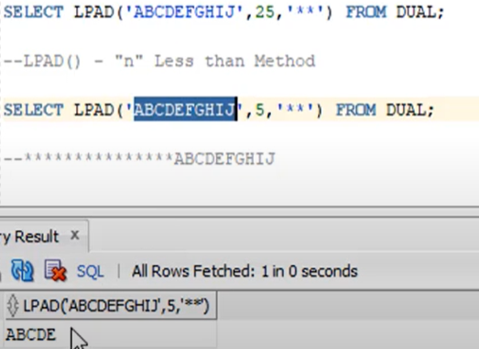

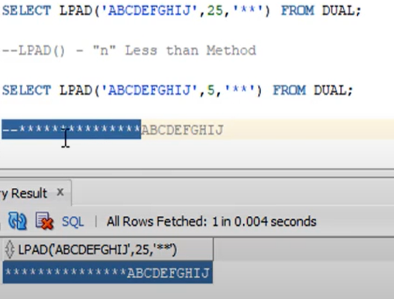

N shiuld be greater than the total length of the Source string(1st Expression).

If it is less, it will print the number of chars from the Source string.

DIFFERENCE BETWEEN:

1. WHILE AND HAVING

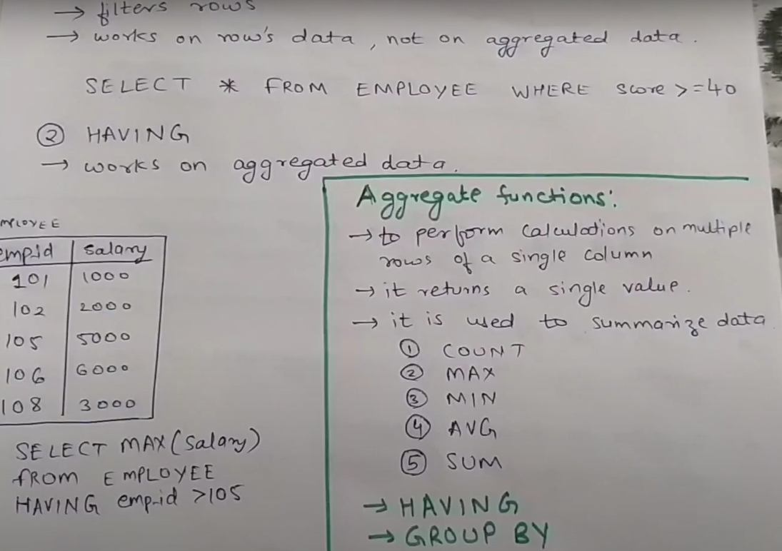

1. UNION AND UNION ALL

Union removes duplicate records while Union All does not.

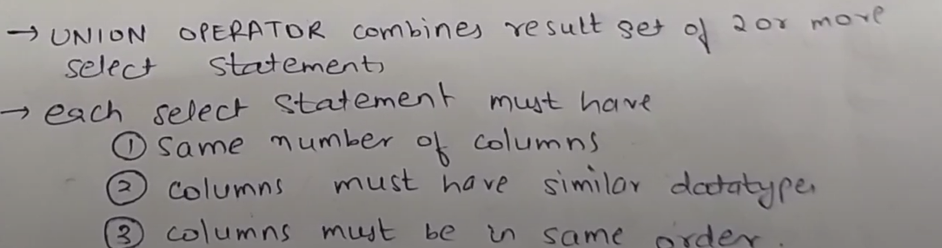

1. IN AND EXISTS

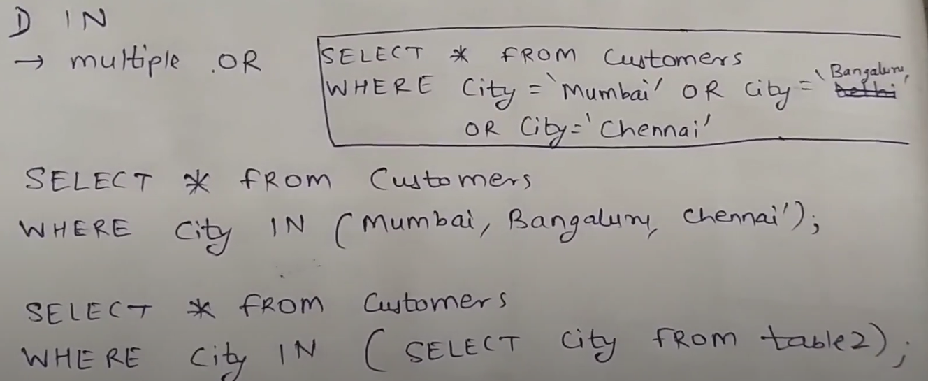

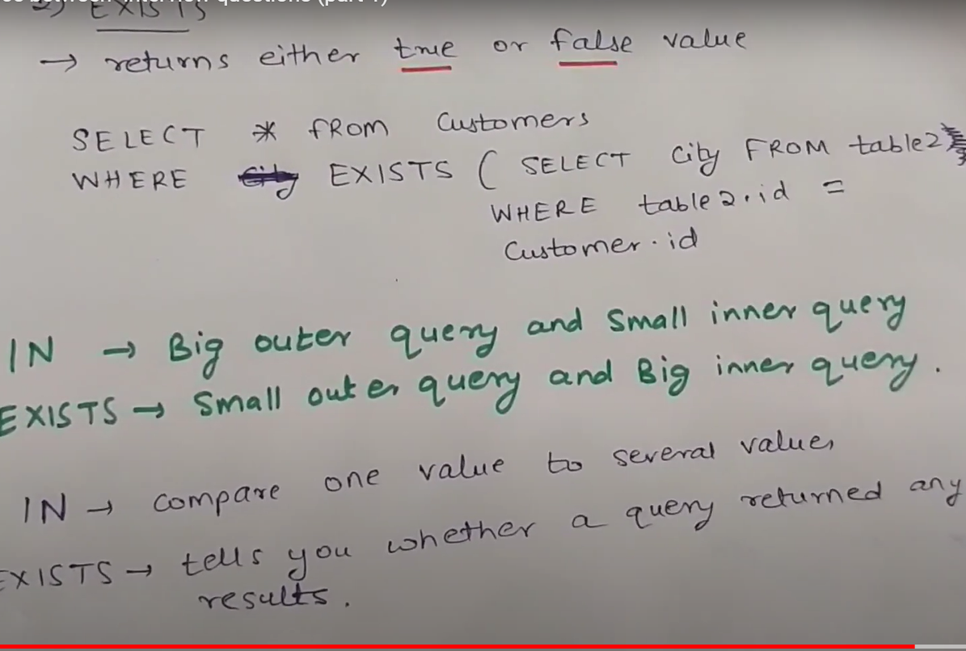

1. GROUP BY AND ORDER BY

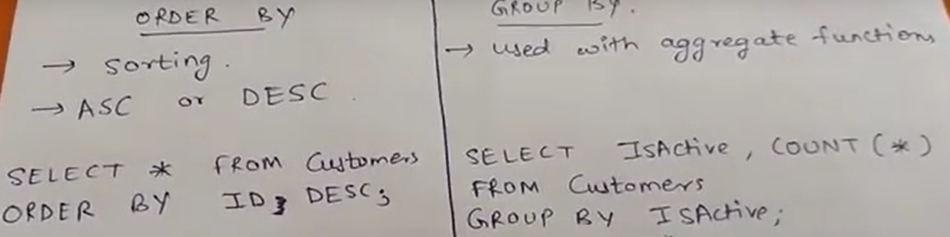

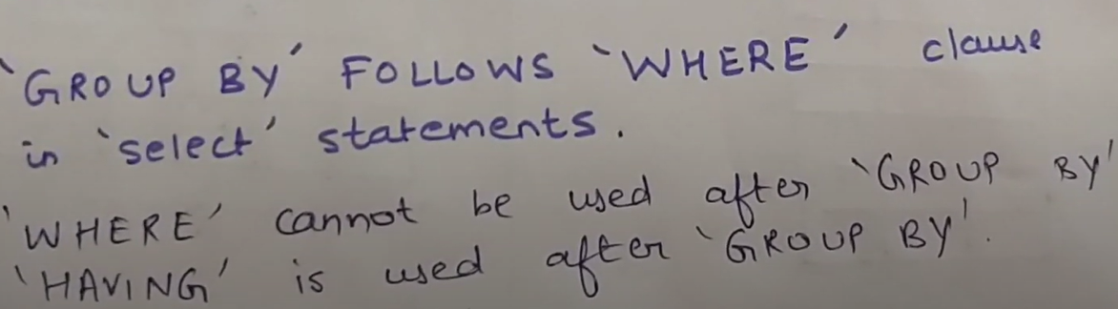

1. JOIN AND SUB QUERY

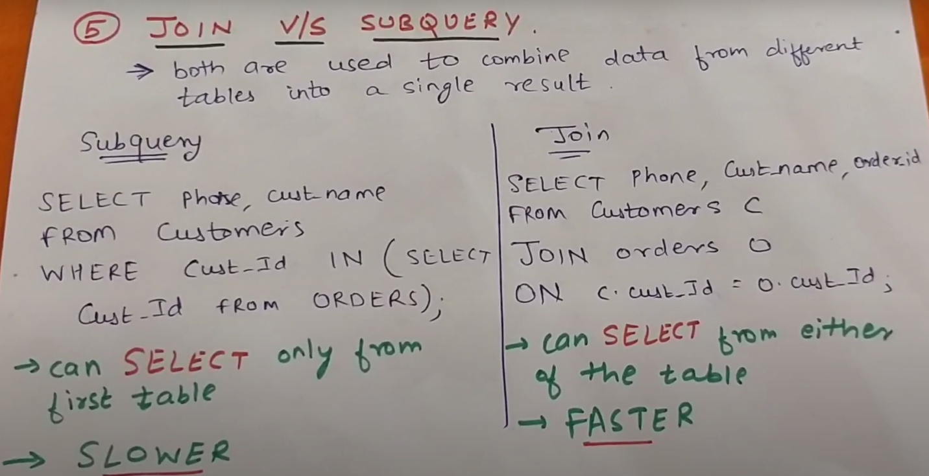

1. JOIN AND UNION

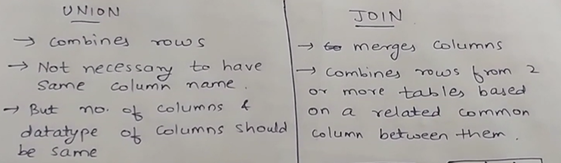

There are four basic Set Operators in SQL Server:

1. Union
2. Union All
3. EXCEPT: The EXCEPT operator lists the rows in the first that are not in the second.
4. INTERSECT: The interest operator keeps the rows that are common to all the queries

**NEED OF NORMALIZATION IN DBMS:**

**Normalization** is the process of minimizing redundancy from a relation or set of relations. Redundancy in relation may cause insertion, deletion and updating anomalies. So, it helps to minimize the redundancy in relations. Normal forms are used to eliminate or reduce redundancy in **database** tables.

Row Level Duplicity and Column Level duplicity

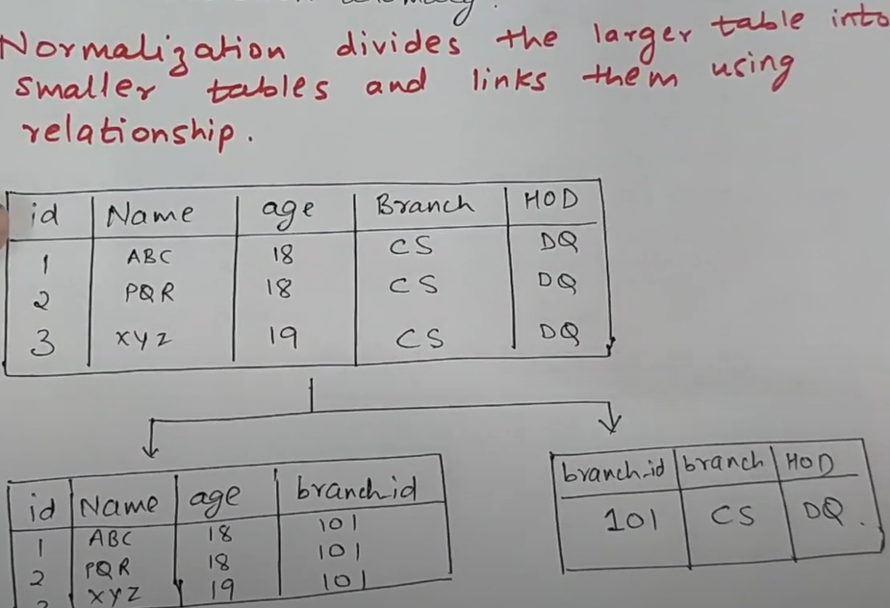

Normalization is basically dividing larger tables into smaller tables and linking them.

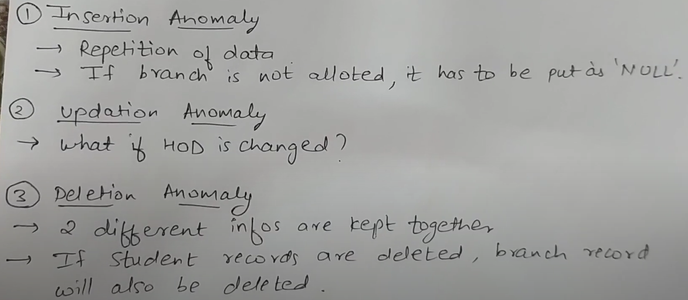

<https://www.youtube.com/watch?v=_C6Bb1OjL2c>

<https://www.youtube.com/watch?v=5GDTIUVlHB8>

**COALEASE vs isNULL vs NVL:**

COALESCE can accept multiple parameters whereas, ISNULL can accept only two parameters. When you use coalesce for replacing nulls with default values, your queries become more portable i.e. you can run them on other databases hence It's recommended to use COALESCE over ISNULL wherever possible

It will take the first occurrence which is not empty. It can also have a default value given at the end.

 NVL function lets you substitute a value when a null value is encountered.

SELECT NVL(commission, 0) FROM sales;

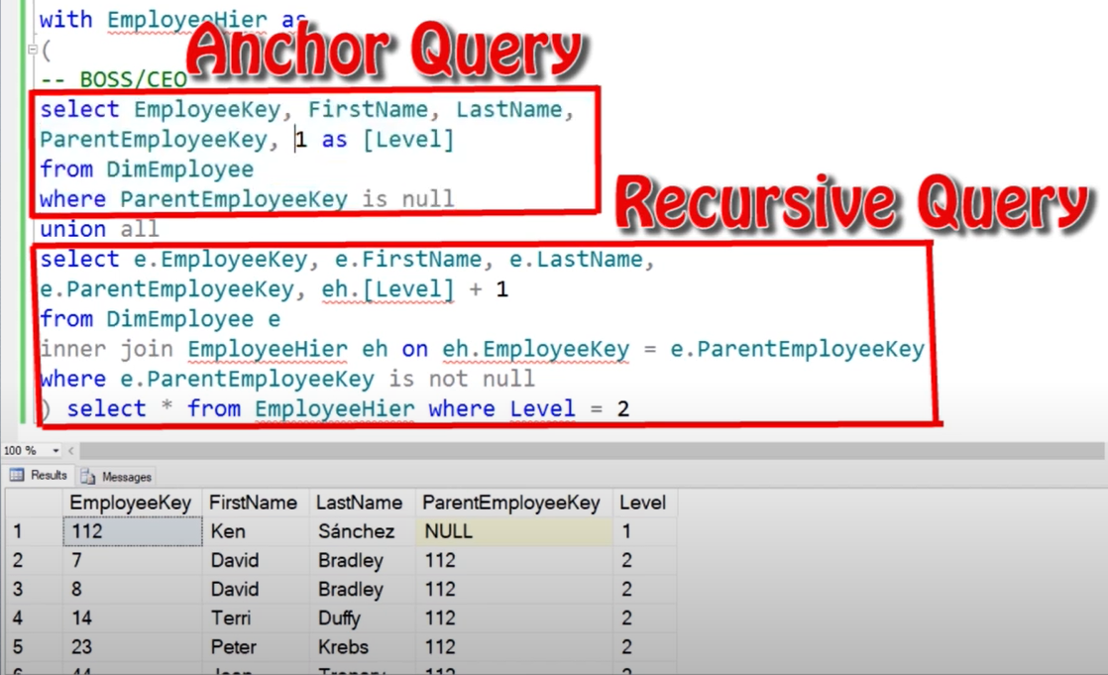

PARTITION BY:

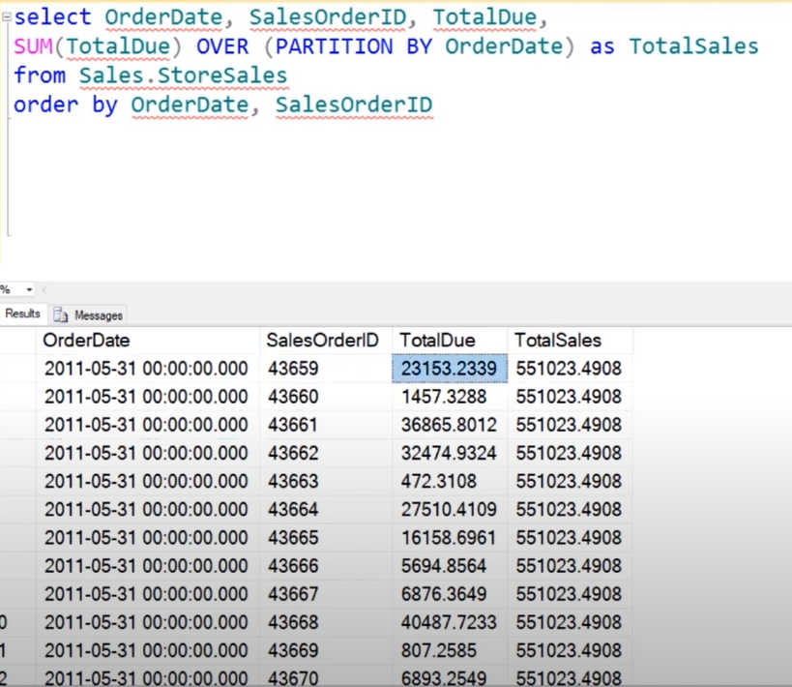

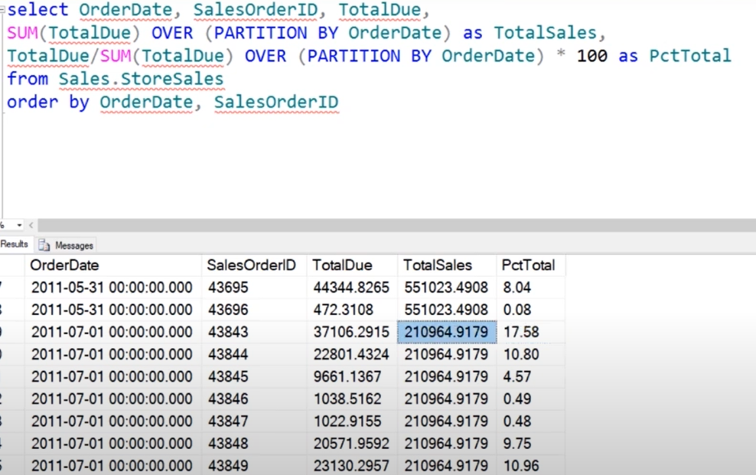

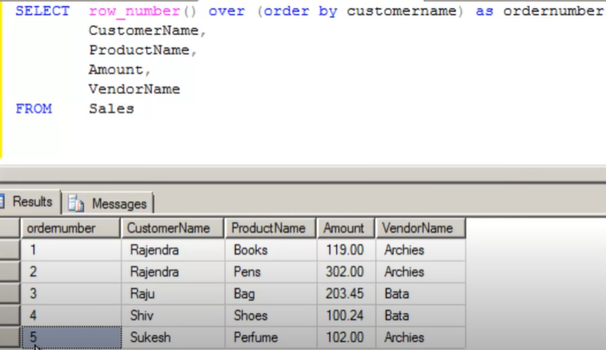

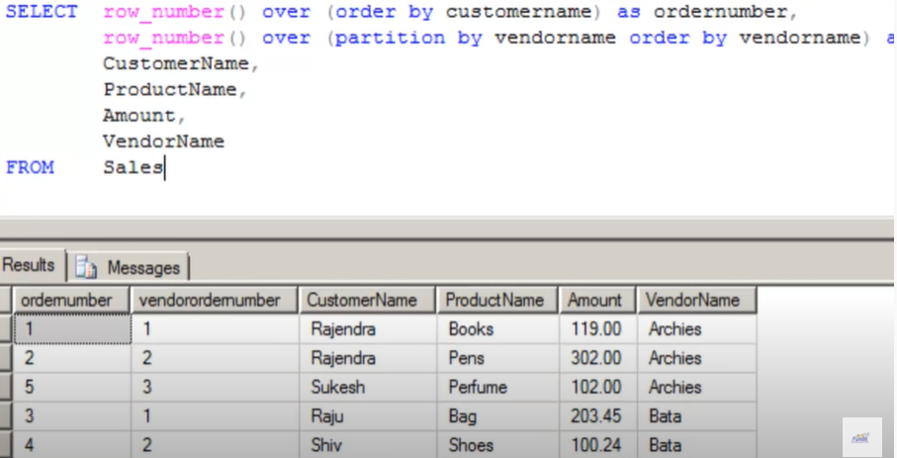

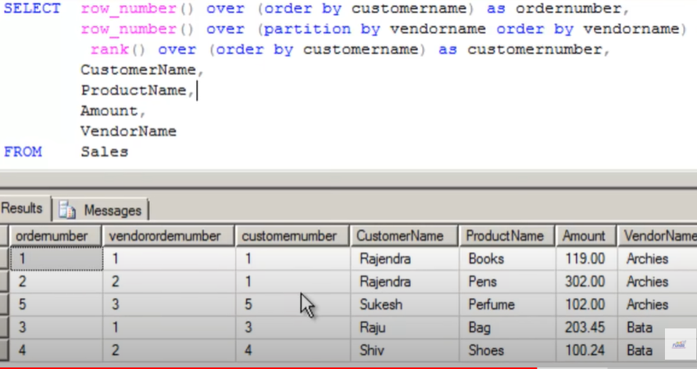

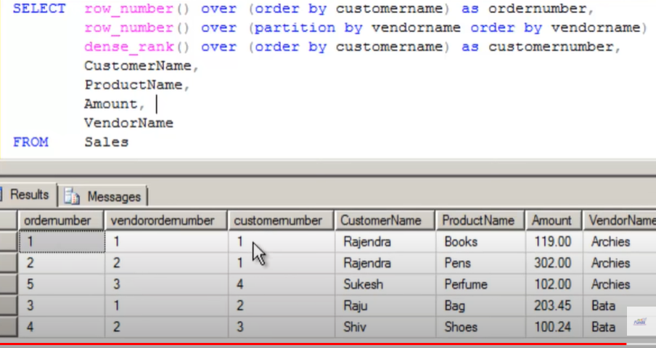

<https://www.youtube.com/watch?v=QFj-hZi8MKk>

QUESTIONS:

1. FIND SECOND HIGHEST SALARY

LIMIT/TOP/MAX

Using MAX:

SELECT MAX FROM EMPLOYEE WHERE SALARAY < (SELECT MAX(salary) FROM EMPLOYEE)

Using LIMIT: LIMIT TAKES ONLY THE SPECIFIC NO OF RECORDS

SELECT SALARY FROM (SELECT SALARY FROM EMPLOYEE ORDER BY SALARY DESC LIMIT **2**) AS EMP

ORDER BY SALARY LIMIT 1;

Using TOP: TAKES ONLY THE TOP SPECIFIC NO OF RECORDS

SELECT TOP 1 SALARY FROM (SELECT TOP 2 SALARY FROM EMPLOYEE ORDER BY SALARY DESC) AS EMP ORDER BY SALARY;

MORE cases of top:

SELECT TOP 50 PERCENT * FROM Customers;

1. CHAR and VARCHAR

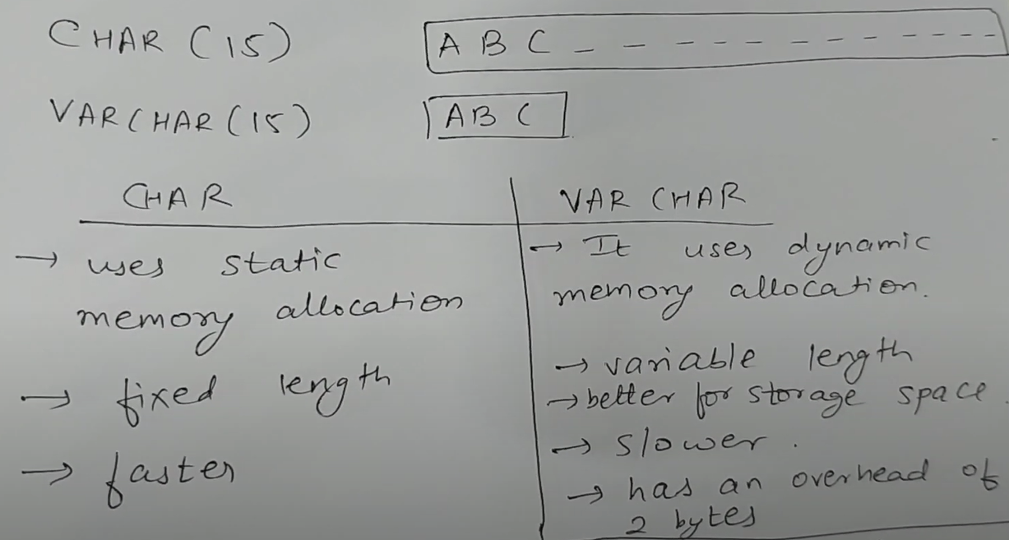

CHAR taken fixed length while VARCHAR takes variable length. Both of them takes 1 byte to store each character but Varchar has overhead of 2 bytes which it used to store the length of the string.

1. JOINS WITH MULTIPLE TABLES:

Select * from employees e INNER JOIN managers m on e.id=m.id INNER JOIN leads l on l.id=m.id

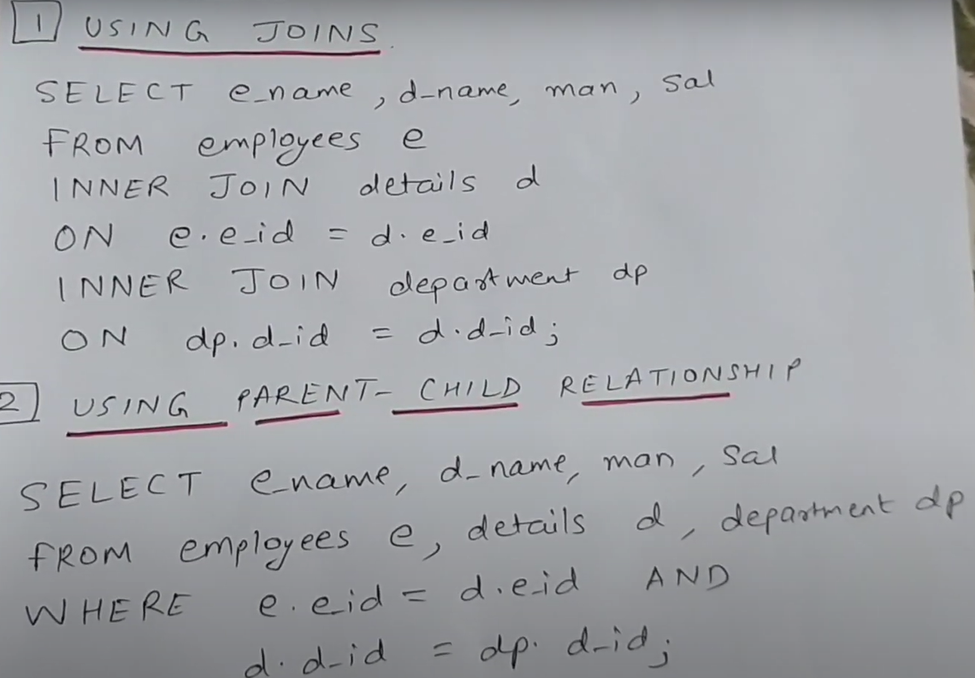

1. QUESTIONS: <https://www.youtube.com/watch?v=d-SJmsgoUrw>

PLSQL::

Cursors:

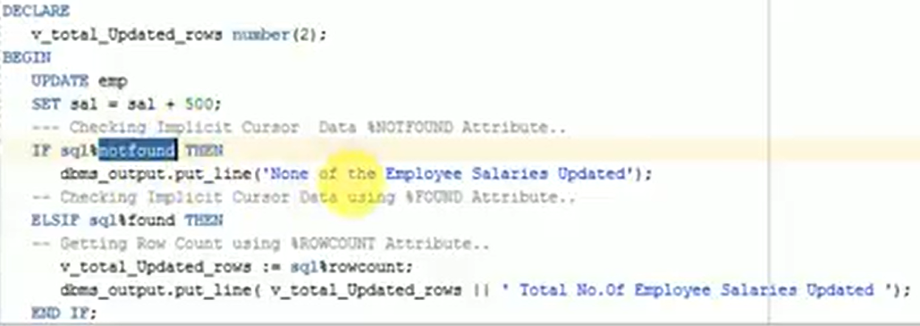

Commit should be used after use of the attributes of cursor. After commit the cursor area is flushed or deleted.

EXPLICIT CURSOR: Decalred in Declaration Section

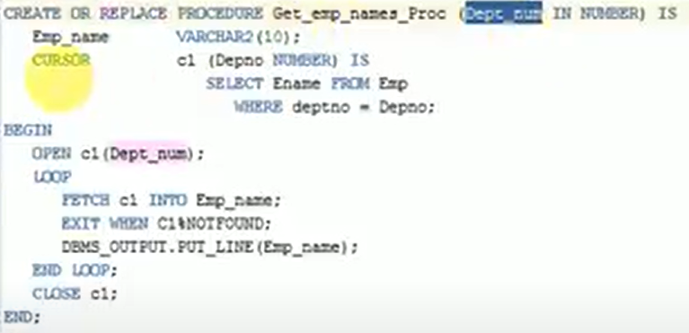

FUNTIONS:

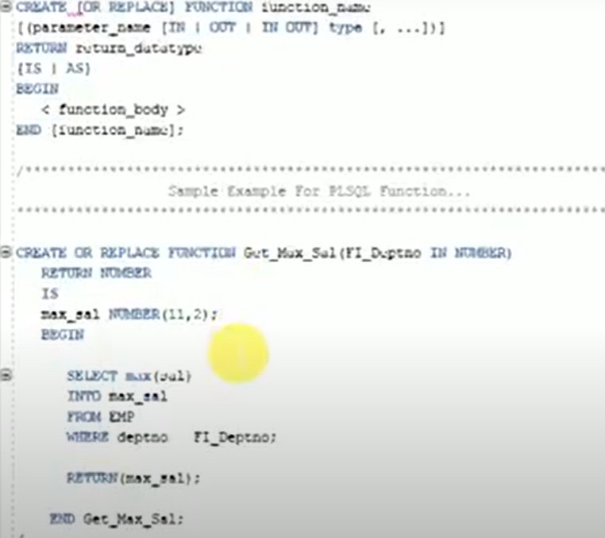

To execute this, we can use a select query – **select get_max_sal(paramater) from dual;**

**PLSQL Functions with OUT Parameter & DML Operations inside Function**

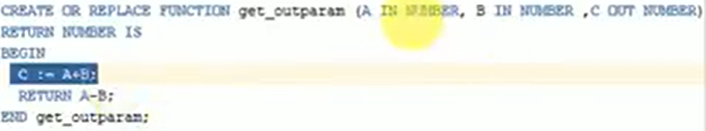

We cannot use select query. We need a reference variable to print return value.

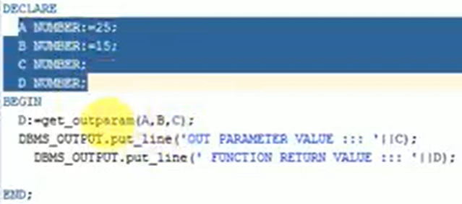

We can use DML statements inside a function or a stored procedure. But the function called be called using a select statement (Will throw cannot call DML operations inside a query). We need to use a PLSQL block to call it.

So, functions can be called in select query provided it neither has an OUT parameter nor a DML statement inside it (Update , Delete)

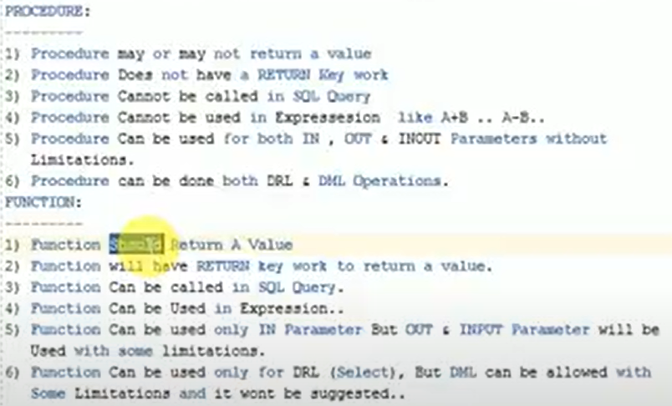

**NVL vs NVL2**

The *nvl*function only has two parameters while the *nvl*parameter has three arguments.  The *nvl2* like like combining an nvl with a decode because you can transform a value:

* NVL ( expr1 , expr2 ): If expr1 is null, then NVL returns expr2. If expr1 is not null, then NVL returns expr1.
* NVL2 ( expr1 , expr2 , expr3 ): If expr1 is null, then NVL2 returns expr3. If expr1 is not null, then NVL2 returns expr2

Any operation with null gives null, so NVL can be used there. All the fields should be of same type here**. NVL (toChar(salary),’ No Salary ’)**